**Game Development**

After every (implementation) commit, *add to the Wiki’s changelog*!

GITHUB WIKI = MAKE CUSTOM SIDEBAR = <https://github.com/adriantanasa/github-wiki-sidebar/wiki>

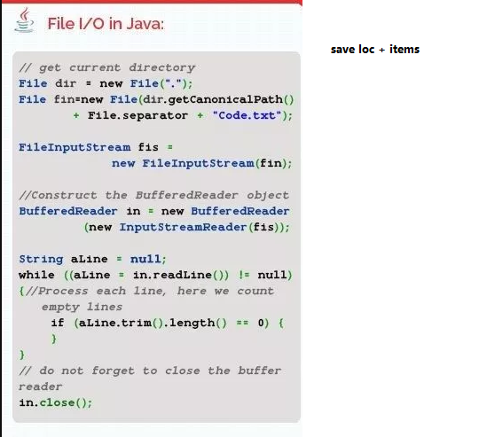

Saving feature = save items and location

|  |  |
| --- | --- |
| **Area** | **Info** |
| **Code Optimizations** | FOR EVERY CLASS = JAVADOC + Fix package imports  Make entity stores static  Make popupdisp global??-draw onto agc?  Make player global?  Make global constructor that is run in loading state?  Move entity processing out of play state  Refactor enemy as protector  Add afterAction and beforeAction as optional methods to entity = can be overridden for any entity = all entities have potential action |
| **Issues to Fix** | Draw layer by layer, and use JProfiler to find issue  Inventory very important  Put faces next to text boxes  CONTROLS PAGE = REMOVE IMAGES, make all text  HINTS = Do one for each CONTROL key = disappears when you do it, use alerts  Make interface for MOVING object = changes over time = works for delay writer + alerts  Make INNO installer file = MAKE java a requirement  GAME ISSUES = Go to Github issues = Better because others can see  CONTROLS =   * Arrow keys or WASD * Actions to   Changes   * INCREASE AREA FOR LIMESTONE OBSTACLE * MOUSE STATS = CHECK = WRONG LETTER! * Prevent ship from disappearing!, only items should go * Create “EventPad” near ship = maybe a white light emitter = this will be area for Finishing scene |
| **Miscellaneous** | Hud shows speed (acutal*10)+ health  MAKE PERFECT COLLISION SYSTEM  CONTROLS PAGE = E means “USE EVERY ITEM GRABBED”  SHIFT =RUN   * Shift down = increase speed by 25% * Shift let go = decrease speed by 25%   Settings have SFX and Music option  Run all sounds thorugh try and catch = so doesn’t crash IDE |
| **Audio** | Get  Use fugue  Menu music  Sound for collecting items  Cryocapacitor use = icy sound  Magistructor orb use = stretching sound |
| **Settings** | Make class for “DynaButton” – A button whose text changes with clikc  Change existing setting to “Debug Mode” : On/Off  Add Screenmode : Windowed (resX and Y subtract 100)or Fullscreen |
| **Minigames** | Minigame  Enemy calss  Boss and Minnion inherit  Hit method =   * Reduce health by incoming * Draw as flicking silhoute (/black or white)   Trevil   * Health bar for trevil but not his minions * Trevil draws health from healthy trees (beside him) * Miniosn come in rows * Player has health * Special push back for Trevil = tiles change, when all different, no more left   Player has internal health, when drops to zero , becomes injured .. must heal itself before doing a challenge = slower movement speed , crawls on ground  Minion class?  Minigame items   * Second cryocapactiro * Can use on trevil or very? * Needs “gyrofocuser” to keep around body and help against Viridash?   Tradeoff for stimulant = damages health and you have to go back to healing pool, says “U druggo. Your skitz now m8!  Wilted big flower   * Poisonous   J   * GasMask * Helps you fight mushroom * Armor * Helps you fight all * Big Flower * Increases health for minigames * Infused with vitality-increasing molecules   Every minigame  Minigames have max 3 tries   * Start = popup = Xaidu preps you   + We’ve got a live one on our hands! Get ready!   + Reading his/her mind, his/her name is _   + Beware of <special attack> (eg. Mycovolence spores spray, Viridash heat, Tree root)   + Enough of your contestant, lets analyse you!     - From the <itemlist> , your health is increased by X% of original (100)     - Due to that slick weapon you’ve got, your damage is X% of original (bare hands)     - What great luck! That <special item> will enable you to resist <something something>   + Your chance of winning is at X% (random 10%)   + Now go get him/her tiger! * Gameplay   + Boss     - Has health too   + Trevil     - top 2 thirds of the screen are covered in small versions of the evil tree (leftover resources)     - They slowly advance. You have to bash your way through them to get to the main tree.     - Just keep coming, speed up over time     - Make them 48x48     - Model columns of them as stacks?     - Special = Root can push you back (represtned as dirt tiles pushing you)   + Mycovolence     - Gross bugs and worms comes from top center (leftover resources) (particle emitter??)     - Touching them makes you lose health     - They can be killed     - Special = You lose health over time due to mushroom spores. Gas mask makes you immune   + Viridash     - Stays in top right     - Sprays fireballs over map     - Special Attack = heat very close to it makes you loose health   + Ship     - Actual cannons surround you (leftover sprites)     - Constantly shooting randomly     - Gunpowder barrels in croner     - You have to hit them and explode them to make nearby cannons disappear     - You win when you destroy them all * End =   + “Xaidu: Well done! You’ve defeated _. We’re getting closer to home!, just keep pressing on” |
| **Opening Cinematic** | A big crashing sound is heard.  The screen slowly fades from black into a scene. |
| **Special Ice Area** | When you destroy dead trees, and you go on big ice square, you get cold  There is a cold meter that rises  If it reaches maximum, you become an somewhat transparent icetile with an alien underneath  You move very slowly  Only way  Extra = This is only way to verse dragon |
| **Inventory** | Modelled as a new state  Background is medium dark brown  There is a grid of all the items you have picked up  Each item has a white background + black square border  Clicking on an item puts a white selection square around it  Information is displayed in a preview area  NO DROP BUTTON  Exit to Game Button  Button makes inventoryOpen = true;   * When inventoryOpen, turn off input * draw a brown square (same X as menu, lower Y) * For every item in player inventory, create a button. This button will load up a popup   Pressing control allows the selection of multiple items  Combine Button |
| **Score** | A “timer” goes during PLAY state and minigames  Score is calculated at end  Starts with large number  Time used = deductions  Lives used = deductions |